LAB 2: AGILE BACKLOG CREATION & SPRINT SIMULATION IN JIRA
Software Engineering Laboratory
Student Name | SIDDESH V S
USN | PES1UG24CS693
Problem Statement | Municipal Infrastructure Damage Reporting App
Domain | Smart Cities, Transport & Logistics
Actors | Citizen Reporter; Municipal Engineer
Lab | Lab 2 – Agile Backlog Creation & Sprint Simulation in Jira

1. Project Basis
This lab builds on my Lab 1 project. In the app, citizens report road potholes, broken streetlights and water pipeline leaks by uploading geotagged photos, and the system sends each ticket to the right municipal engineering department. There are two actors: the Citizen Reporter and the Municipal Engineer.

2. Proposed Epics & User Stories
Epic | User Story | Jira Key | User Story Description | Priority | SP
Epic 1: Damage Reporting (SCRUM-5) | US-1.1 | SCRUM-7 | As a Citizen Reporter, I want to submit a damage report with the damage type, description and photo, so that the municipality receives complete information about the infrastructure damage. | Highest | 5
Epic 1: Damage Reporting (SCRUM-5) | US-1.2 | SCRUM-8 | As a Citizen Reporter, I want the app to extract GPS information from my uploaded damage photo, so that the exact incident location can be identified. | Highest | 5
Epic 1: Damage Reporting (SCRUM-5) | US-1.3 | SCRUM-9 | As a Citizen Reporter, I want to receive confirmation after submitting a damage report, so that I know my complaint has been successfully recorded. | Medium | 3
Epic 2: Municipal Response & Ticket Management (SCRUM-6) | US-2.1 | SCRUM-10 | As a Municipal Engineer, I want damage reports to be automatically routed to the relevant engineering department, so that the responsible department can take action. | Highest | 5
Epic 2: Municipal Response & Ticket Management (SCRUM-6) | US-2.2 | SCRUM-11 | As a Municipal Engineer, I want to update the status of a damage ticket, so that the progress of the reported issue can be tracked. | Highest | 3
 |  |  | Total planned story points |  | 21

5. Jira Screenshots

5.1 Screenshot S1 – Jira Backlog
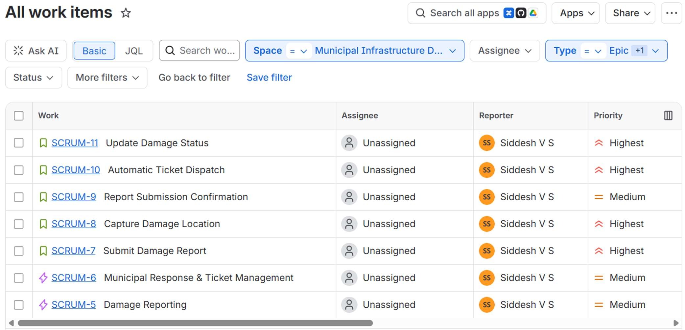

5.2 Screenshot S2 – Priority & Story Points
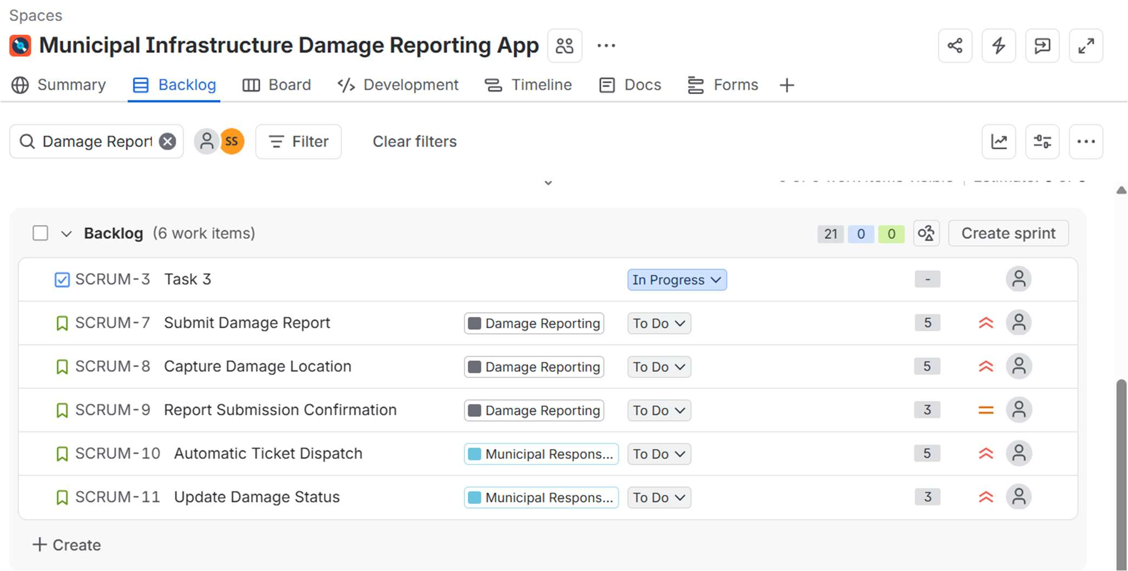

5.3 Screenshot S3 – Sprint 1 Planning
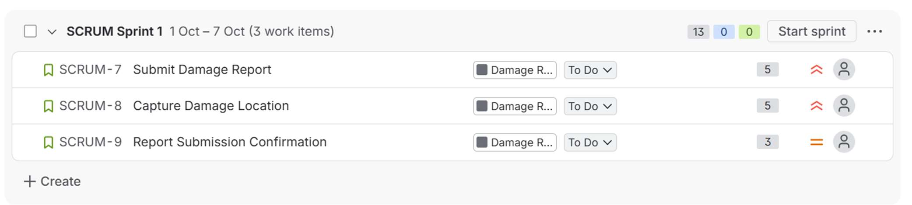

5.4 Screenshot S4 – Active Sprint Board (Sprint 1)
S4a – Start of sprint
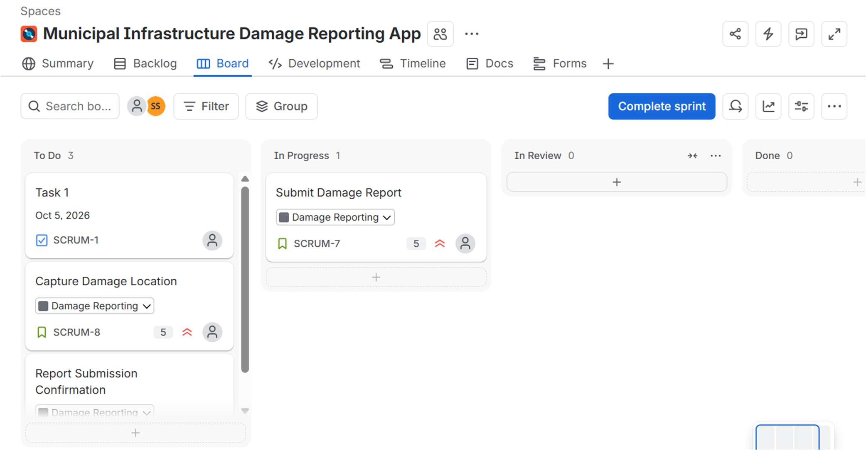
S4b – Mid-sprint
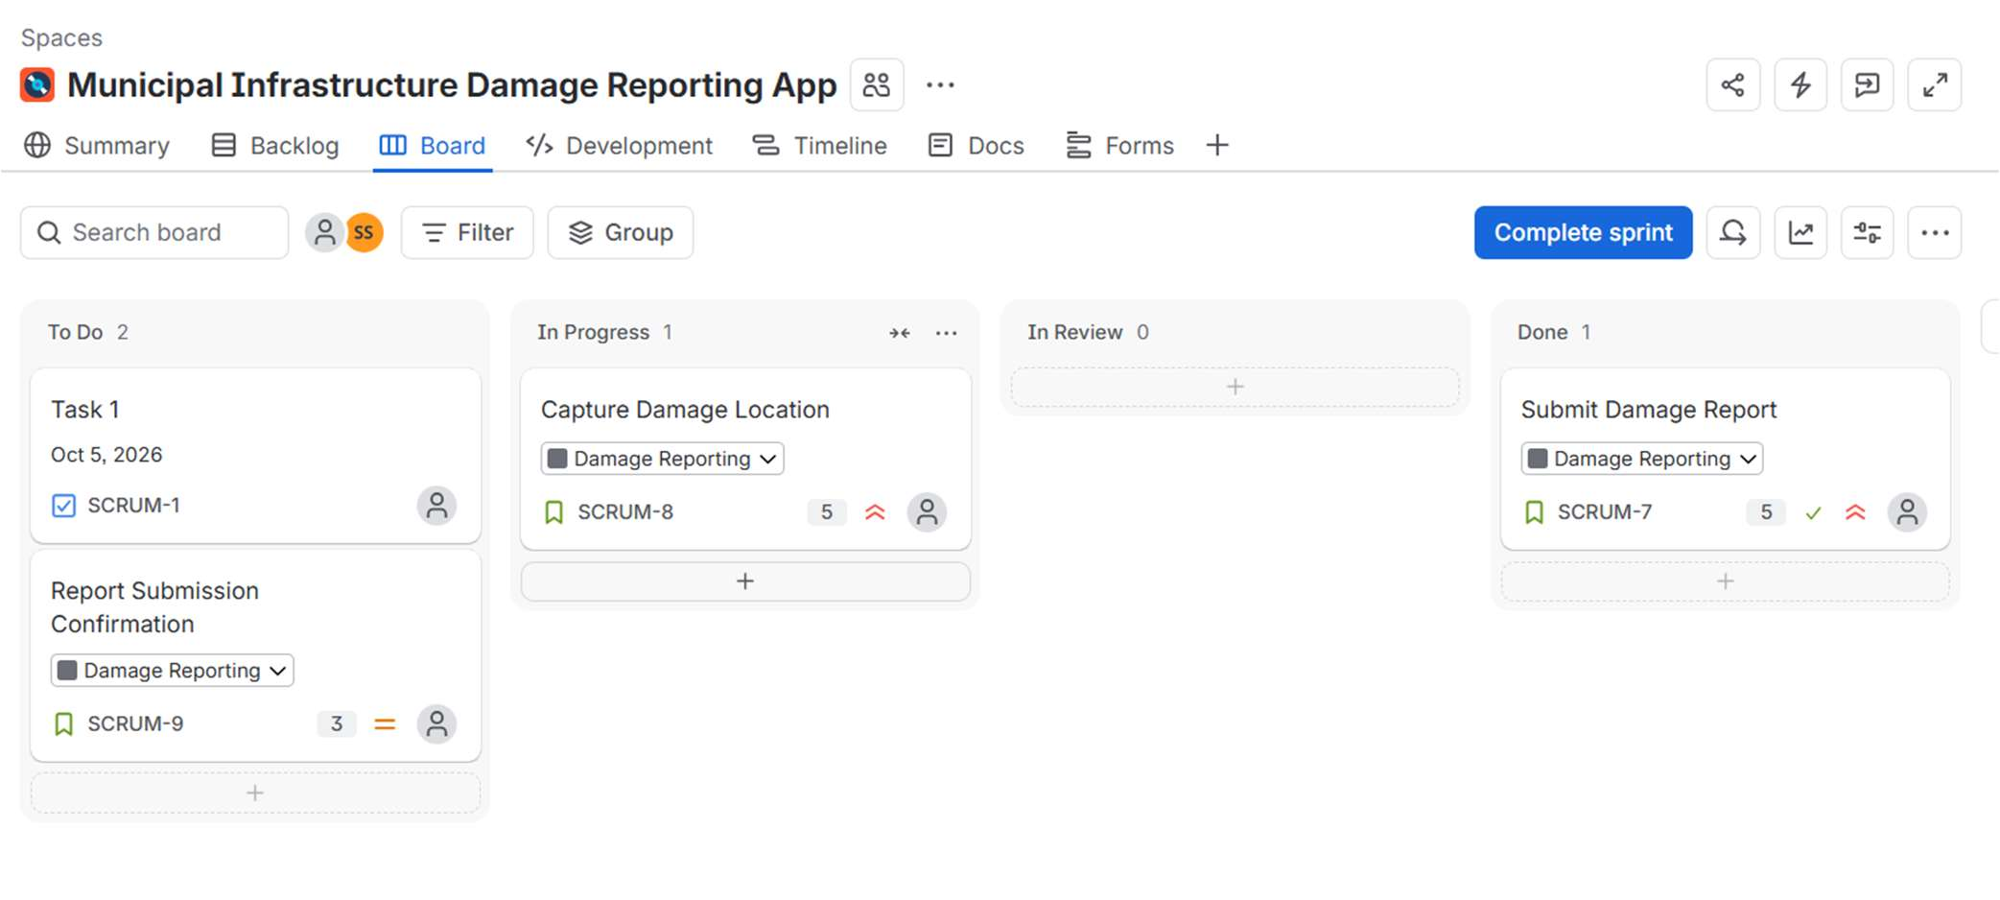
S4c – Late sprint
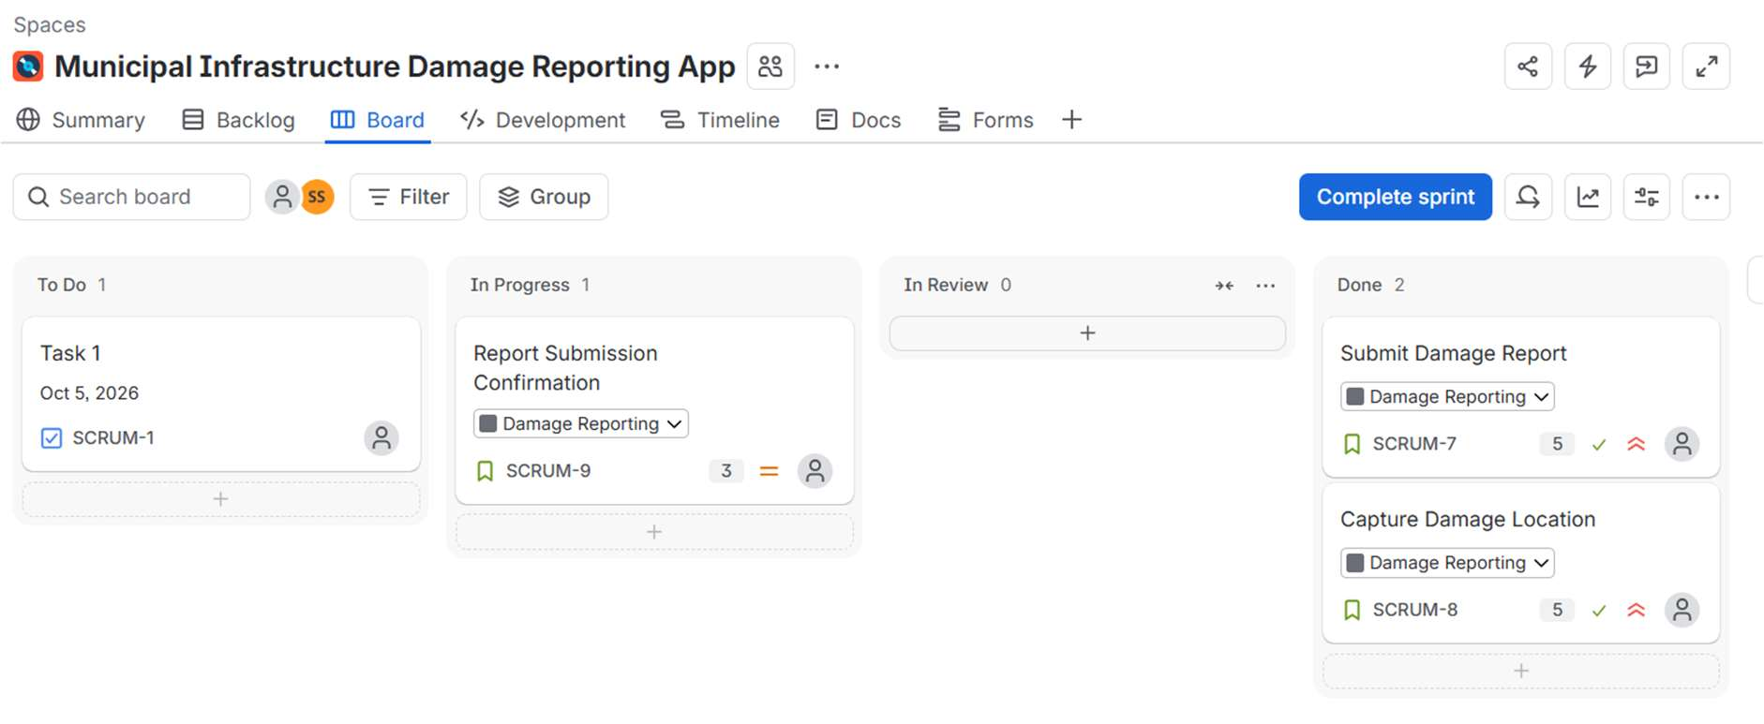

5.5 Screenshot S5 – Completed Sprint
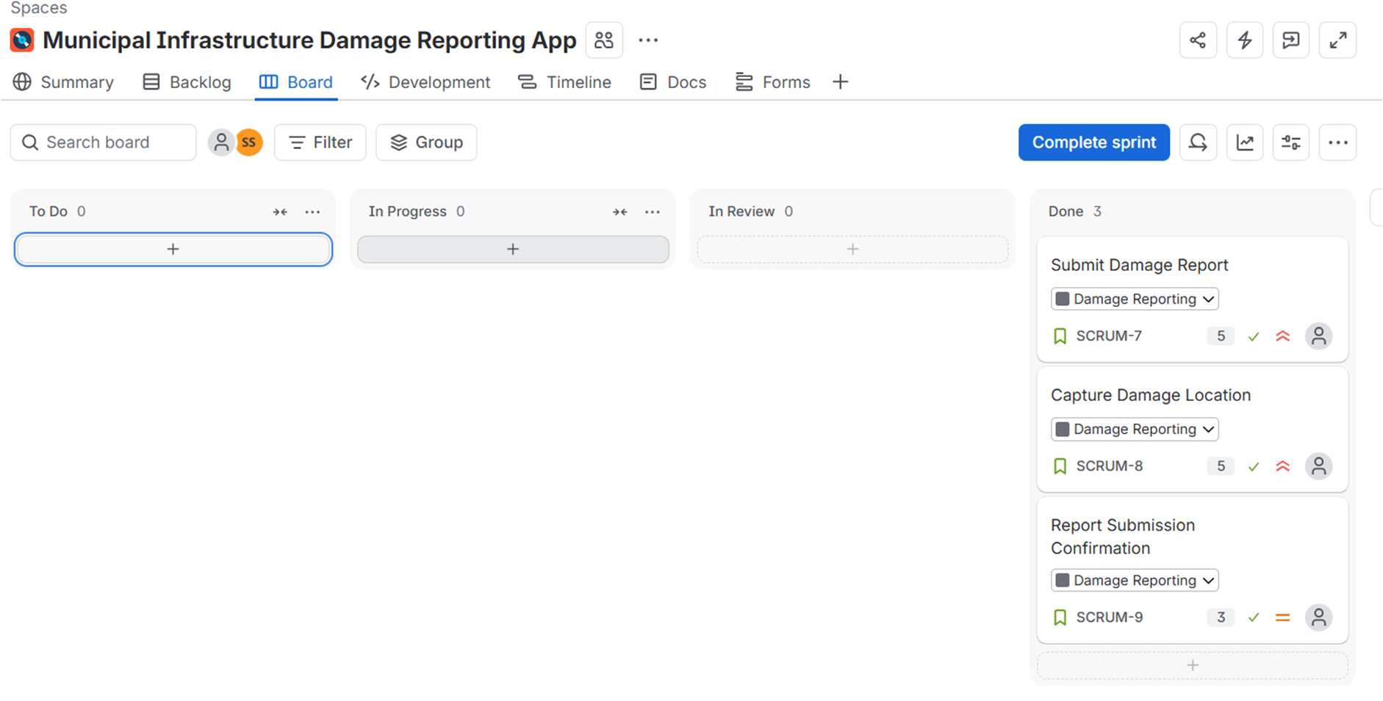

5.6 Screenshot S6 – Sprint 2
S6a – Sprint 2 start
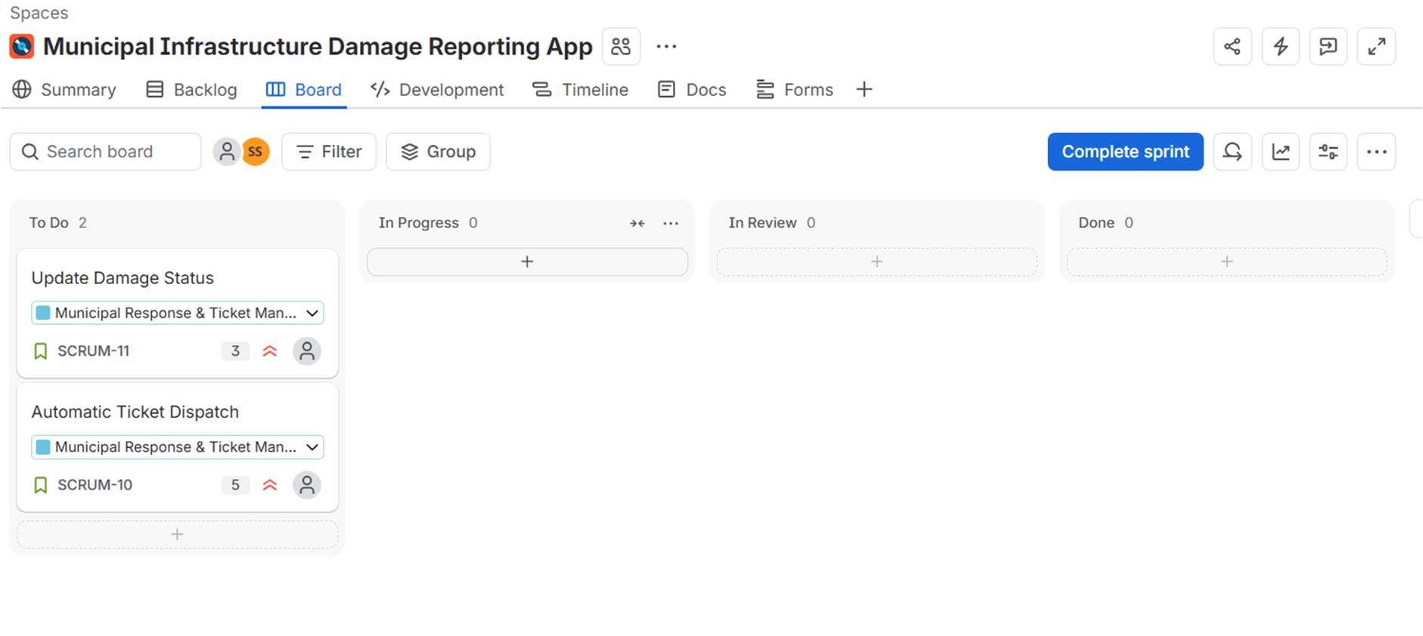
S6b – Sprint 2 completion
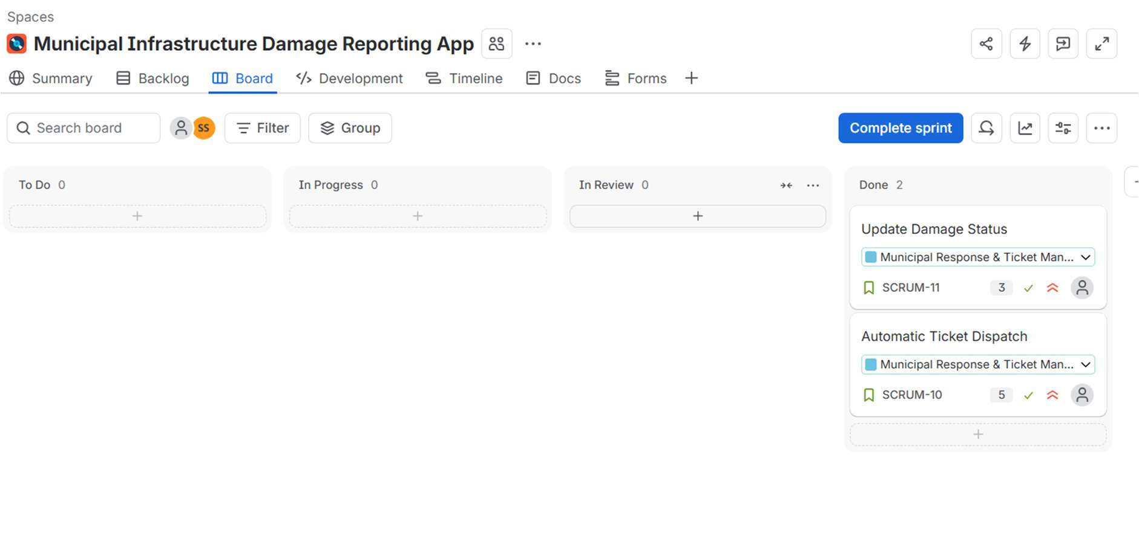

5.7 Screenshot S7 – Burndown Chart
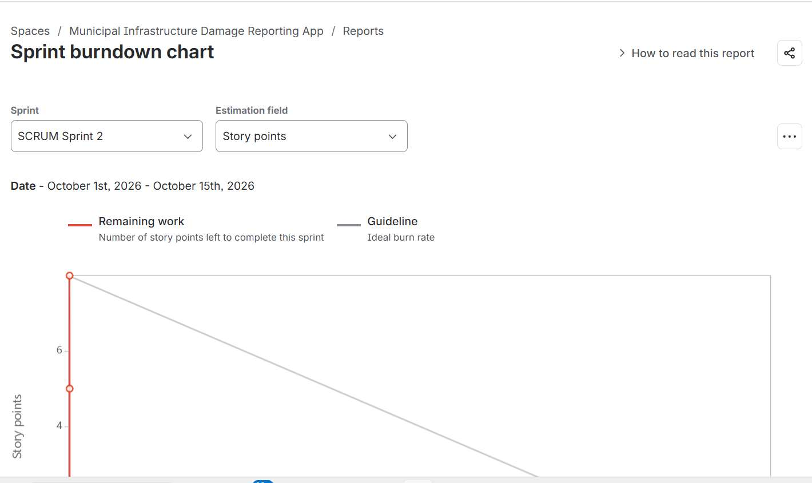

6. Reflection Questions
1. Did your story point estimates reflect the actual effort?
Overall, my estimates were reasonable for this simulation. I gave 5 points to Submit Damage Report and Capture Damage Location because both involve more than one step. The first includes the report form and photo upload, while the second depends on reading GPS information from the photo. I gave Report Submission Confirmation 3 points because it is a smaller change. In Sprint 2, Automatic Ticket Dispatch received 5 points because it involves routing the report to the correct department, while Update Damage Status received 3 points.
Because this was a simulated sprint, the story points represent relative effort rather than actual hours. I did not need to change any estimates during the sprint. In a real project, Capture Damage Location could take longer than expected if a photo does not contain GPS information.
2. Was your backlog well-prioritized?
Yes, the backlog was planned in a logical order. I put the three citizen-facing stories in Sprint 1 because they form the basic reporting flow: submit the report, identify the location, and confirm that it was received. The two municipal response stories were placed in Sprint 2 because the ticket needs to exist before it can be routed and updated.
If I were improving the backlog, I would add a story that lets a citizen choose a location manually on the map. That would provide a backup when an uploaded photo does not contain GPS information.
3. How did your simulated sprint align with your plan?
The simulated sprints followed the original plan closely. Sprint 1 was planned for 13 story points and all 13 were completed. Sprint 2 was planned for 8 points and all 8 were completed, giving a total of 21 completed points. I also moved the stories through the expected workflow from To Do to In Progress and then Done. No story had to be carried over or split.
4. What insights did the burndown chart give about your team’s capacity?
The two sprints gave me a rough idea of the amount of work I could handle in this simulation: 13 points in Sprint 1 and 8 points in Sprint 2. Since this was only a short simulation, I would use this as a rough reference rather than a fixed capacity for a real project.
The Sprint 2 burndown starts at 8 points and falls in steps instead of following the guideline smoothly. This happened because I moved the stories to Done fairly quickly during the simulation. In a real sprint, updating the board regularly would give a more realistic picture of progress and make it easier to notice if the team was falling behind.

